Payments and Reconciliation

1. **Create Payment IHB Forecast Rule** (Generate forecast for payments)
   1. Go to Security Settings
   2. Select Payment Setup (Under Payment Security)
   3. Select Payment IHB and Forecast Rules and create new one for account (1234567891011)

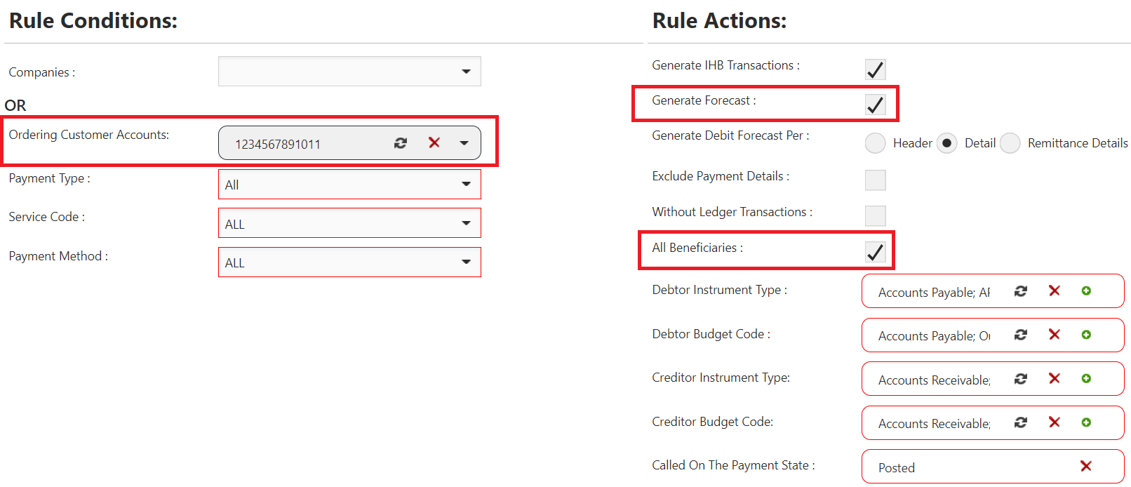

Notes: While creating the rule, specify the **Ordering Customer Account**, **Generate Forecast** to have an automatic forecast generated for the selected account in case of a payment and include **All Beneficiaries**. The forecast is very important to be defined at which stage it will be generated (in the above screenshot as shown in the last field it is selected on “Posted” payment).

* 1. Save the Payment IHB and Forecast Rule

1. **Create Reconciliation Rule** (To reconcile payment generated forecast with imported bank statement)
   1. Go to Reconciliation Rules and create new one (Account 1234567891011)
   2. Select to apply it on Debit, Credit or Both

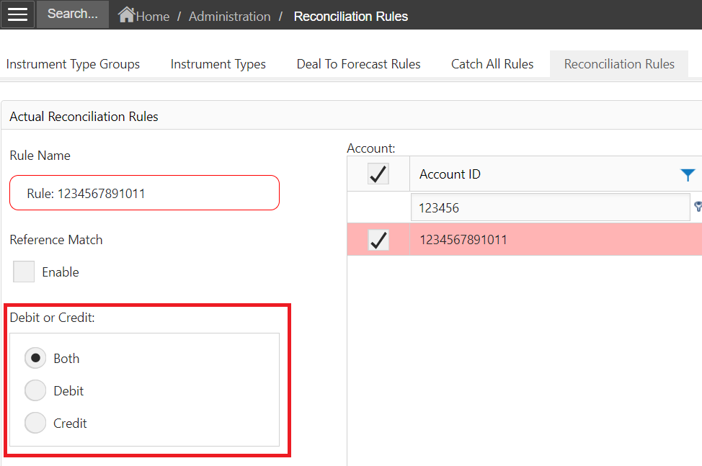

* 1. Specify the acceptable difference amount, and date difference (Value and Entry date), Bank code, instrument type and budget code.

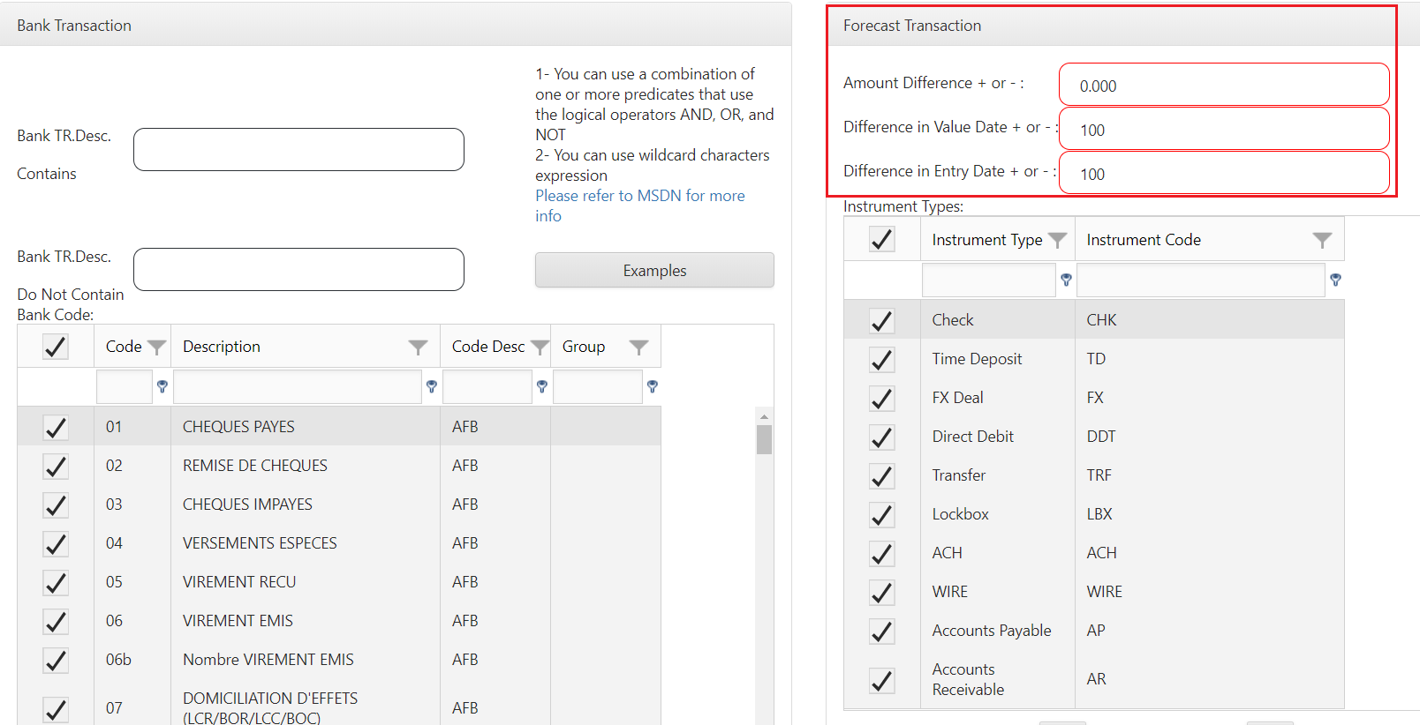

* 1. Select the ledger account affected

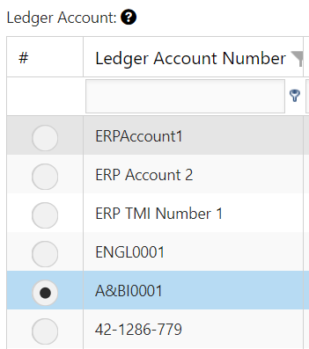

* 1. Save the Reconciliation rule

1. **Create Payment from Payment editor OR Import payment file**
   1. Create manual payment from payment editor or Import payment file having transactions for the account number (1234567891011)
   2. Go to Daily Treasury, Step 1: Pending Statement
   3. Check the forecast transactions

Before Payment creation (no forecast transaction is available for the payment as shown below)

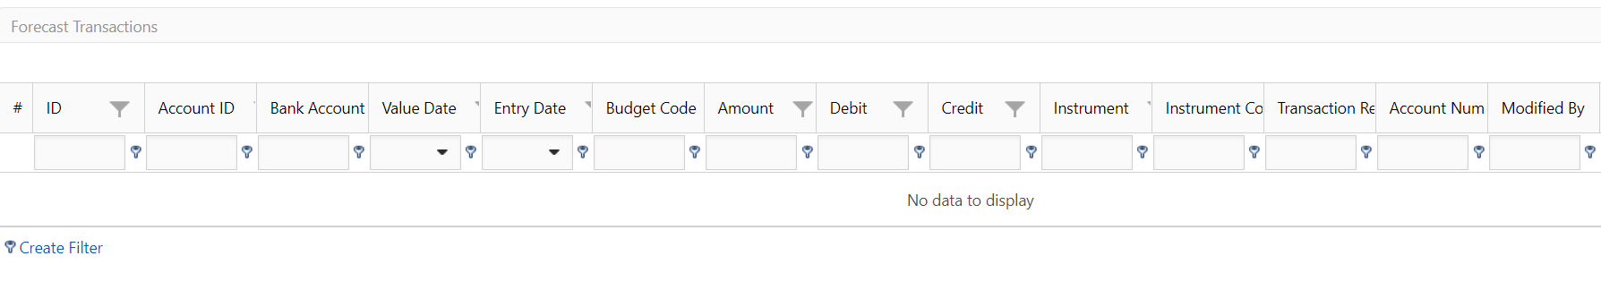

After Payment creation (forecast transaction is available as generated based on payment IHB Rule)

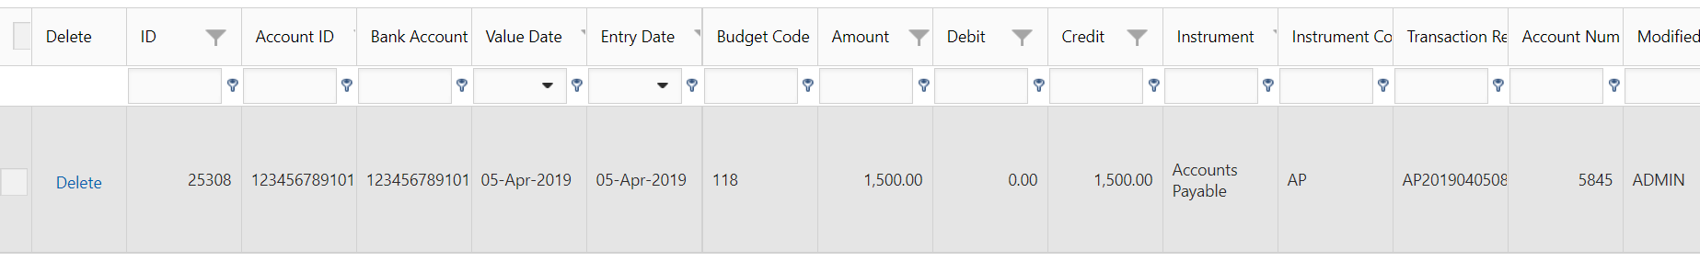

1. **Import Bank Statement File (MT940)**
   1. Go to manual bank integration
   2. Import Bank Statement File (MT940) having transaction with details matching the payment previously created
   3. Then go to Daily Treasury, Step 1: Pending Statements
   4. Check Bank Transactions and Forecast Transactions (transactions should be reconciled)

